Prime Number

Aim
To check whether a given number is prime using RAPTOR.

Apparatus Required
- Computer/Laptop
- RAPTOR Software
- Windows Operating System

Procedure
- Open RAPTOR.
- Input a number.
- Count the number of factors.
- Check whether the factor count is equal to 2.
- Display whether the number is prime or not.
- Execute the flowchart.
Flowchart
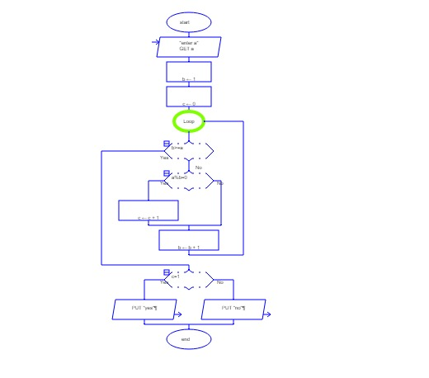
Input
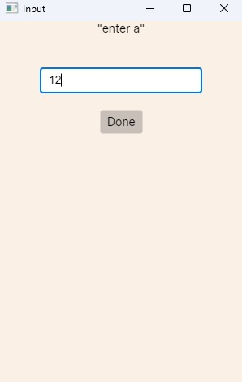
Output
